**FORMULARIO DE DESCRIPCIÓN VARIETAL**

**DE ZAPALLOS (*Cucurbita spp.*)**

* **CALABACÍN (*Cucurbita moschata*)**
* **KABUTIÁ (*Cucurbita máxima x Cucurbita moschata*)**
* ***Cucurbita máxima***

|  |
| --- |
| Nombre propuesto del cultivar: |
| Nombre definitivo del cultivar*: |
| Lugar y año de las observaciones realizadas: |
|  |

(*) A completar por INASE

## I. DESCRIPCIÓN DEL CULTIVAR

1. **Planta: longitud del tallo principal**

|  |  |  |  |  |  |  |  |  |
| --- | --- | --- | --- | --- | --- | --- | --- | --- |
| 1. Muy corta |  | 3. Corta |  | 5. Media |  | 7. Larga | 9. Muy larga |  |

1. **Planta: porte**

|  |  |  |  |  |  |
| --- | --- | --- | --- | --- | --- |
| 3. Arbustivo |  | 5. Semirastrero |  | 7. Rastrero |  |

1. **Tallo: color**

|  |  |  |  |
| --- | --- | --- | --- |
| 1. Completamente verde |  | 2. Amarillo y verde |  |

1. **Limbo: incisiones**

|  |  |  |  |  |  |  |  |  |  |
| --- | --- | --- | --- | --- | --- | --- | --- | --- | --- |
| 1. Ausentes o muy poco profundas |  | 3. Poco profundas |  | 5. Media |  | 7. Profundas |  | 9. Muy profundas |  |

1. **Limbo: manchas plateadas**

|  |  |  |  |
| --- | --- | --- | --- |
| 1. Ausente |  | 9. Presente |  |

1. **Flor femenina: anillo en la parte interna de la corola**

|  |  |  |  |
| --- | --- | --- | --- |
| 1. Ausente |  | 9. Presente |  |

1. **Flor masculina: color del anillo de la parte interna de la corola**

|  |  |  |  |  |  |  |
| --- | --- | --- | --- | --- | --- | --- |
| 1. Amarillo |  | 2. Verde |  |  | 3. Amarillo y verde |  |

1. **Pedúnculo: longitud**

|  |  |  |  |  |  |  |  |  |  |  |
| --- | --- | --- | --- | --- | --- | --- | --- | --- | --- | --- |
| 1. Muy corto |  | 3. Corto |  |  | 5. Medio |  | 7. Largo |  | 9. Muy largo |  |

1. **Fruto joven: color principal de la epidermis (excluido el color del acostillado o de acanaladuras)**

|  |  |  |  |  |  |  |  |  |  |  |
| --- | --- | --- | --- | --- | --- | --- | --- | --- | --- | --- |
| 1. Blanco |  | 2. Crema |  |  | 3. Amarillo |  | 4. Verde |  | 5. Blanco y amarillo |  |

|  |  |
| --- | --- |
| 6. Blanco y verde |  |

1. **Fruto: longitud**

|  |  |  |  |  |  |  |  |  |  |  |
| --- | --- | --- | --- | --- | --- | --- | --- | --- | --- | --- |
| 1. Muy corto |  | 3. Corto |  |  | 5. Medio |  | 7. Largo |  | 9. Muy largo |  |

1. **Fruto: diámetro**

|  |  |  |  |  |  |  |  |  |  |  |
| --- | --- | --- | --- | --- | --- | --- | --- | --- | --- | --- |
| 1. Muy pequeño |  | 3. Pequeño |  |  | 5. Medio |  | 7. Grande |  | 9. Muy grande |  |

1. **Fruto: relación longitud/diámetro**

|  |  |  |  |  |  |  |  |  |  |  |
| --- | --- | --- | --- | --- | --- | --- | --- | --- | --- | --- |
| 1. Muy pequeña |  | 3. Pequeña |  |  | 5. Media |  | 7. Grande |  | 9. Muy grande |  |

1. **Fruto: forma en sección longitudinal (sólo para Zapallito y Kabutiá)**

|  |  |  |  |  |  |  |
| --- | --- | --- | --- | --- | --- | --- |
| 1. Acorazonada |  | 2. En turbante |  |  | 3. Elíptica transversal media |  |

|  |  |  |  |  |  |  |  |  |
| --- | --- | --- | --- | --- | --- | --- | --- | --- |
| 4. Elíptica transversal ancha |  | 5. Circular |  |  | 6. Elíptica estrecha |  | 7. Elíptica media |  |

|  |  |  |  |  |  |  |  |  |
| --- | --- | --- | --- | --- | --- | --- | --- | --- |
| 8. Rectangular |  | 9. Trapezoidal |  |  | 10. Piriforme ancha |  | 11. Piriforme estrecha |  |

1. **Fruto: posición de la parte más ancha**

|  |  |  |  |  |  |  |
| --- | --- | --- | --- | --- | --- | --- |
| 1. Hacia la base |  | 2. En el medio |  |  | 3. Hacia el ápice |  |

1. **Fruto: forma general (sólo para Calabacín)**

|  |  |  |  |  |  |  |
| --- | --- | --- | --- | --- | --- | --- |
| 1. En forma de disco |  | 2. Elíptica transversal media |  |  | 3. Elíptica transversal ancha |  |

|  |  |  |  |  |  |  |  |  |  |  |
| --- | --- | --- | --- | --- | --- | --- | --- | --- | --- | --- |
| 4. Globular |  | 5. En forma de tocado |  |  | 6. Elíptica ancha |  | 7. Oval |  | 8. Elíptica |  |

|  |  |  |  |  |  |  |  |  |
| --- | --- | --- | --- | --- | --- | --- | --- | --- |
| 9. Cilíndrica |  | 10. En forma de pera |  |  | 11. En forma de botella |  | 12. En forma de maza |  |

1. **Fruto: perfil en la base**

|  |  |  |  |  |  |  |  |  |
| --- | --- | --- | --- | --- | --- | --- | --- | --- |
| 1. Elevado |  | 2. Plano |  |  | 3. Ligeramente deprimido |  | 4. Moderadamente deprimido |  |

|  |  |
| --- | --- |
| 5. Fuertemente deprimido |  |

1. **Fruto: surcos**

|  |  |  |  |
| --- | --- | --- | --- |
| 1. Ausente |  | 9. Presente |  |

1. **Fruto: número de colores de piel**

|  |  |  |  |  |  |  |
| --- | --- | --- | --- | --- | --- | --- |
| 1. Uno |  | 2. Dos con límites bien definidos |  |  | 3. Dos tonos cromáticos |  |

|  |  |
| --- | --- |
| 4. Más de dos tonos o intensidades con límites definidos |  |

1. **Fruto: color a la madurez**

|  |  |  |  |  |  |  |  |  |  |  |
| --- | --- | --- | --- | --- | --- | --- | --- | --- | --- | --- |
| 1. Blanco |  | 2. Crema |  |  | 3. Amarillo |  | 4. Verde |  | 5. Blanco y amarillo |  |

|  |  |  |  |  |  |  |  |  |  |  |
| --- | --- | --- | --- | --- | --- | --- | --- | --- | --- | --- |
| 6. Blanco y verde |  | 7. Amarillo y verde |  |  | 8. Anaranjado |  | 9. Rosa |  | 10. Rojo |  |

|  |  |  |  |  |
| --- | --- | --- | --- | --- |
| 11. Verde grisáceo |  | 12. Gris |  |  |

1. **Fruto: sólo variedades con dos o más tonos cromáticos, color secundario de la piel**

|  |  |  |  |  |  |  |  |  |  |  |
| --- | --- | --- | --- | --- | --- | --- | --- | --- | --- | --- |
| 1. Blanco |  | 2. Crema |  |  | 3. Amarillo |  | 4. Verde |  | 5. Blanco y amarillo |  |

|  |  |  |  |  |  |  |  |  |  |  |
| --- | --- | --- | --- | --- | --- | --- | --- | --- | --- | --- |
| 6. Blanco y verde |  | 7. Amarillo y verde |  |  | 8. Anaranjado |  | 9. Rosa |  | 10. Rojo |  |

|  |  |  |  |  |
| --- | --- | --- | --- | --- |
| 11. Verde grisáceo |  | 12. Gris |  |  |

1. **Fruto: sólo variedades con dos o más tonos cromáticos, distribución del color secundario**

|  |  |  |  |  |  |  |
| --- | --- | --- | --- | --- | --- | --- |
| 1. Únicamente en manchas |  | 2. En manchas y franjas |  |  | 3. Únicamente en franjas |  |

1. **Fruto: formación suberosa**

|  |  |  |  |  |  |  |
| --- | --- | --- | --- | --- | --- | --- |
| 1. Ausente o muy débil |  | 2. En puntos |  |  | 5. Reticular |  |

1. **Fruto: verrugas en la epidermis**

|  |  |  |  |
| --- | --- | --- | --- |
| 1. Ausente |  | 9. Presente |  |

1. **Fruto: color de la pulpa**

|  |  |  |  |  |  |  |  |  |  |  |
| --- | --- | --- | --- | --- | --- | --- | --- | --- | --- | --- |
| 1. Blanco |  | 2. Crema |  |  | 3. Amarillo |  | 4. Anaranjado |  | 5. Anaranjado rojizo |  |

1. **Fruto: estructura de la pulpa**

|  |  |  |  |
| --- | --- | --- | --- |
| 1. No fibrosa |  | 2. Fibrosa |  |

1. **Fruto: duración de la conservación**

|  |  |  |  |  |  |  |  |  |  |  |
| --- | --- | --- | --- | --- | --- | --- | --- | --- | --- | --- |
| 1. Muy corta |  | 3. Corta |  |  | 5. Media |  | 7. Larga |  | 9. Muy larga |  |

1. **Semilla: tamaño**

|  |  |  |  |  |  |  |  |  |  |  |
| --- | --- | --- | --- | --- | --- | --- | --- | --- | --- | --- |
| 1. Muy pequeña |  | 3. Pequeña |  |  | 5. Media |  | 7. Grande |  | 9. Muy grande |  |

1. **Semilla: forma**

|  |  |  |  |  |  |  |
| --- | --- | --- | --- | --- | --- | --- |
| 3. Elíptica estrecha |  | 5. Elíptica media |  |  | 7. Elíptica ancha |  |

1. **Semilla: color del tegumento**

|  |  |  |  |  |  |  |
| --- | --- | --- | --- | --- | --- | --- |
| 3. Blanco |  | 5. Crema |  |  | 7. Marrón claro |  |

1. **Ciclo:**

|  |
| --- |
|  |

Días de siembra a fin de cosecha

1. **Enfermedades**

Inmune a:

|  |
| --- |
|  |
|  |
|  |

Resistente a:

|  |
| --- |
|  |
|  |
|  |

Susceptible a:

|  |
| --- |
|  |
|  |
|  |

1. **Plagas**

Resistente a:

|  |
| --- |
|  |
|  |
|  |

Susceptible a:

|  |
| --- |
|  |
|  |
|  |

## II. CULTIVARES SIMILARES Y SUS DIFERENCIAS RESPECTO AL CULTIVAR CANDIDATO

Utilice el cuadro adjunto para proporcionar la información sobre la característica (o las características)

en las cuales el cultivar candidato difiere del cultivar (o cultivares) más parecido (o más parecidos).

|  |  |  |  |
| --- | --- | --- | --- |
| Denominación de los cultivares similares al candidato | Características en las que el cultivar candidato difiere de lo(s) cultivar(es) similar(es) | Descripción de la expresión de la(s) característica(s) para los cultivar(es) similar(es) | Descripción de la expresión de la(s) característica(s) para su cultivar candidato |
|  |  |  |  |
|  |  |  |  |
|  |  |  |  |
|  |  |  |  |
|  |  |  |  |
|  |  |  |  |
|  |  |  |  |
|  |  |  |  |
|  |  |  |  |
|  |  |  |  |

## III. EXPLICACIONES DE LAS CARACTERÍSTICAS

**N° 4 Limbo: incisiones**

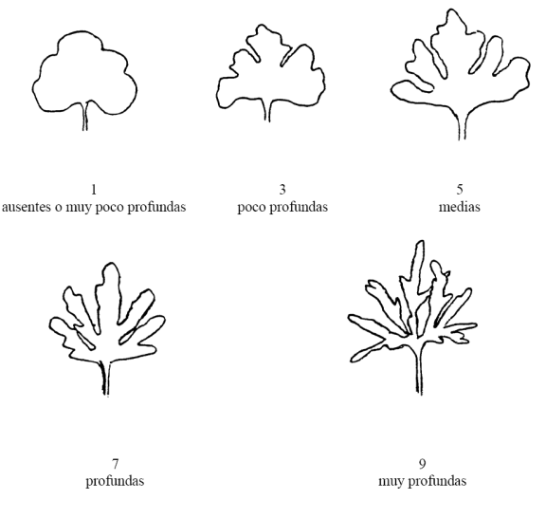

**N° 13 Fruto: forma sección longitudinal (Sólo para Zapallito y Kabutiá)**

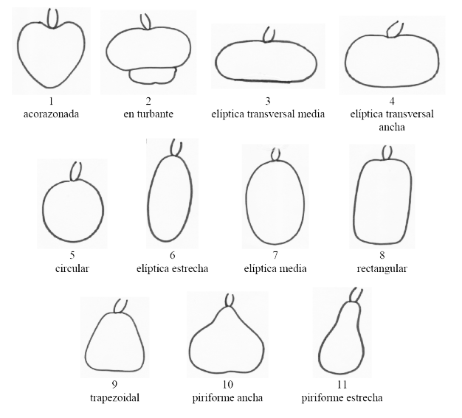

**N° 15 Fruto: forma general (sólo para Calabacín)**

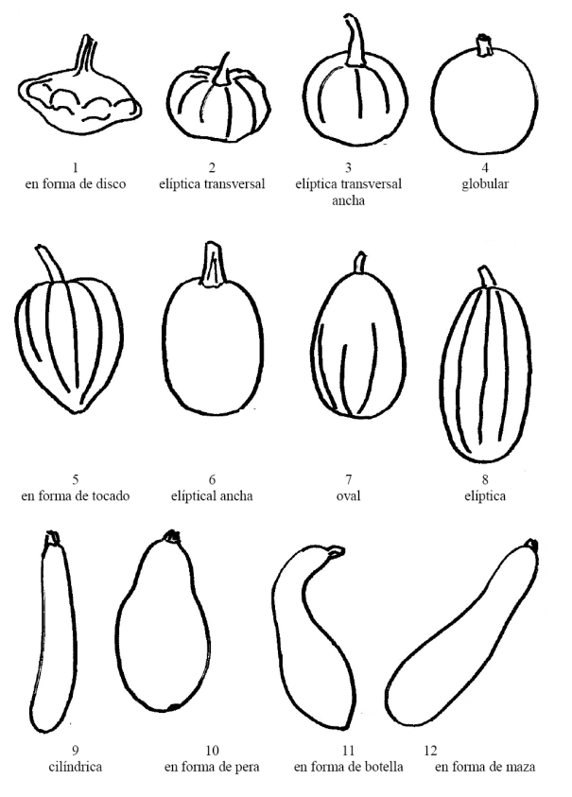

**N°16 Fruto: perfil en la base**

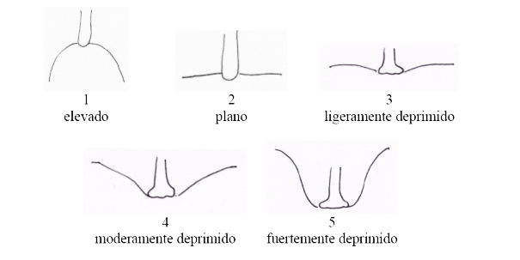

**N° 22 Fruto: formación suberosa**

## 

## IV. RESPONSABLES

|  |
| --- |
|  |

Lugar y fecha: ­­­­­­­­­

_________________________________________ _________________________________________

Firma del Ing. Agr. patrocinante Firma del solicitante o

representante autorizado

|  |
| --- |
|  |

|  |
| --- |
|  |

Aclaración de Firma Aclaración de Firma